7. Breadth-First Search (BFS)
Aim
To implement the Breadth-First Search (BFS) algorithm to traverse a graph.

Algorithm
- Create a graph using an adjacency list.
- Create a queue and a visited set.
- Insert the starting node into the queue.
- Remove a node from the queue.
- If it is not visited, print it and mark it as visited.
- Add all unvisited adjacent nodes to the queue.
- Repeat until the queue is empty.

Pseudocode
Start
Create graph
Create queue and visited list
Insert starting node into queue

While queue is not empty
Remove front node
If node is not visited
Visit node
Add adjacent nodes to queue
End While

Stop

Code:
from collections import deque

graph = {
'A': ['B', 'C'],
'B': ['D', 'E'],
'C': ['F'],
'D': [],
'E': ['F'],
'F': []
}

visited = set()
queue = deque(['A'])

while queue:
node = queue.popleft()

if node not in visited:
print(node, end=" ")
visited.add(node)
queue.extend(graph[node])

Output:
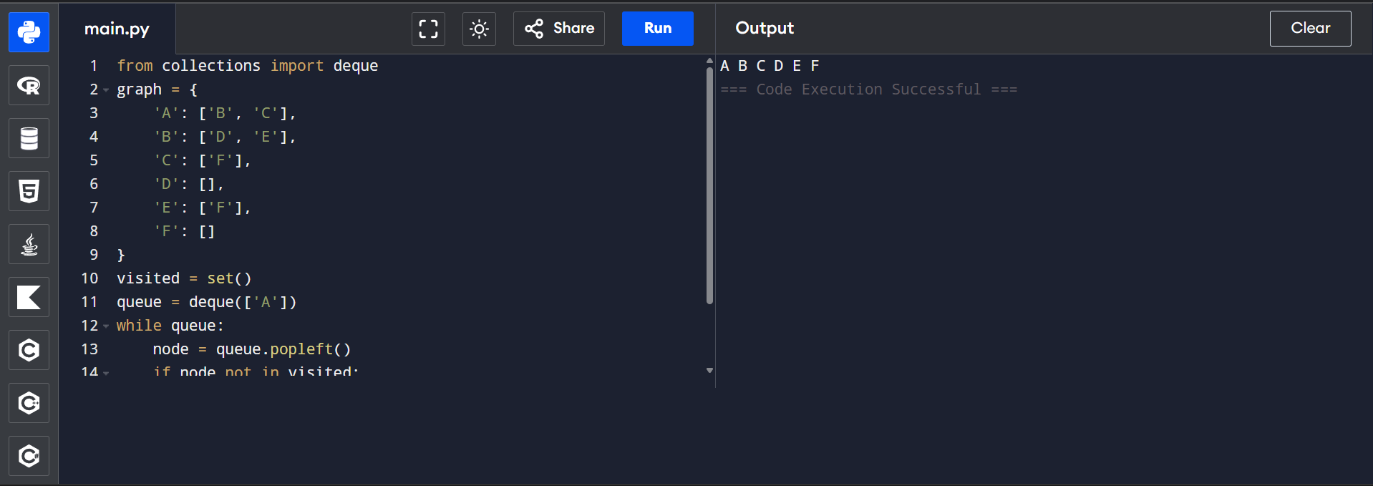

8. Depth-First Search (DFS)

Aim
To implement the Depth-First Search (DFS) algorithm to traverse a graph.

Algorithm
- Create a graph using an adjacency list.
- Create a visited set.
- Start from the source node.
- Visit the node and mark it as visited.
- Recursively visit all unvisited adjacent nodes.
- Continue until all nodes are visited.

Pseudocode:
StartStart
Create graph
Mark all nodes as unvisited

DFS(node)
Visit node
Mark node as visited
For each adjacent node
If not visited
DFS(adjacent node)

Stop

Code:

graph = {
'A': ['B', 'C'],
'B': ['D', 'E'],
'C': ['F'],
'D': [],
'E': ['F'],
'F': []
}

visited = set()

def dfs(node):
if node not in visited:
print(node, end=" ")
visited.add(node)

for neighbor in graph[node]:
dfs(neighbor)

dfs('A')

Output:
